How to Set Up Your Sponsor Booth

At the AgriVoltaics2022 conference, you can present your company in one of our digital sponsor booths on the conference platform SCOOCS.

Sample Booth:

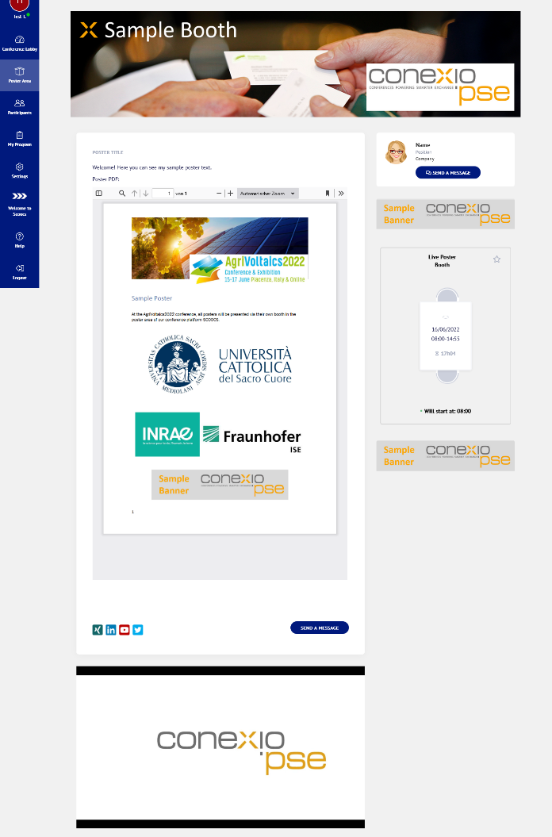

- To set up your virtual booth, please log into the AgriVoltaics2022 virtual conference platform.
  - First step: Check-in
    - Follow this link: https://agrivoltaics2022-conference.scoocs.co/checkin
    - Use the email address to which the sponsor booth message was sent to check in.
    - Once you are in, complete your profile and set a password.

  - Subsequent log-in:
    - For all future log-ins, simply go to the log-in page:
https://agrivoltaics2022-conference.scoocs.co/login
    - Use your e-mail address and the password that you defined when you registered
    - If you do not remember your password, simply request a new password.

- Once you are logged in, click on "Sponsor Area" on the left in the menu. Then click on the "Create Booth" button at the top right.

- Choose between 2D or 3D booth.
- You can now enter your details, upload your company materials including PDFs, images, text, and embedding a video (e.g. via YouTube). Click here for a quick tutorial on how to add a PDF or image.
IMPORTANT: Please make sure you adhere to the platform recommendations regarding the size of your uploaded content (simply hover over the respective info icon to see the ideal format).
- You can also complete your contact details, add a representative and your social media links.

- You can also set up a booth networking table by marking the respective box at the bottom right and entering the time and date you are available for a video chat. (Always set the limit registrations to 100.)
- Once your booth is ready, you need only tick the "Active" box at the top right of the page to make it visible for attendees (see image below, highlighted in yellow):

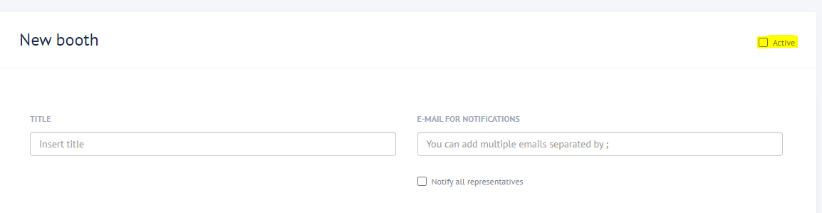
- If you click on "Sponsor Area" on the left menu, you should now be able to see the virtual booth you just created. You can edit your booth by clicking on "Edit Booth" at the top. Attendees will have access to the platform starting Friday, June 10, 2022.
- Please note that your sponsor booth will be assigned to its category by the conference organizers after you finished your set-up.

If you have any questions, do not hesitate to reach out to us at info@agrivoltaics-conference.org!

Thank you for supporting our conference! We are looking forward to your presence at the AgriVoltaics2022!

The AgriVoltaics Organizing Team

