How to Set Up Your Poster Booth

At the AgriVoltaics2022 conference, all posters will be presented via their own booth in the poster area of our conference platform SCOOCS.

Sample Booth:

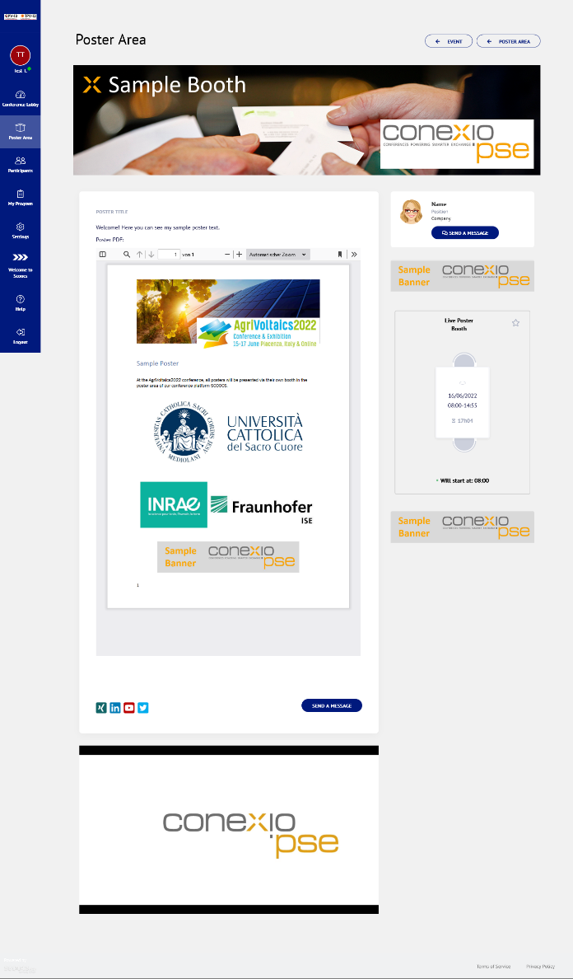

- To set up your virtual booth, please log into the AgriVoltaics2022 virtual conference platform.
  - First step: Check-in
    - Once you have registered for the conference, simply follow this link: https://agrivoltaics2022-conference.scoocs.co/checkin
    - Use the email address with which you registered for the conference to check in.
    - Once you are in, complete your profile and set a password.

  - Subsequent log-in:
    - For all future log-ins, simply go to the log-in page:
https://agrivoltaics2022-conference.scoocs.co/login
    - Use your e-mail address and the password that you defined when you registered
    - If you do not remember your password, simply request a new password.

- Once you are logged in, click on "Poster Area" on the left in the menu. Then click on the "Create Poster" button at the top right.
- You can now enter your details, upload your poster PDF and complete the booth content by adding text, additional pictures, banners and embedding a video (e.g. via YouTube). Click here for a quick tutorial on how to add your poster PDF.
IMPORTANT: Please make sure you adhere to the platform recommendations regarding the size of your uploaded content (simply hover over the respective info icon to see the ideal format).
- You can also complete your contact details, add a representative and your social media links.

- Be sure to set up a booth networking table and name it “Live Poster Booth” by marking the respective box at the bottom right and entering the aforementioned title as well as the time and date of your poster session. Set the limit registrations to 100.
- Once your poster booth is ready, you need only tick the "Active" box at the top right of the page to make it visible for attendees (see image below, highlighted in yellow):

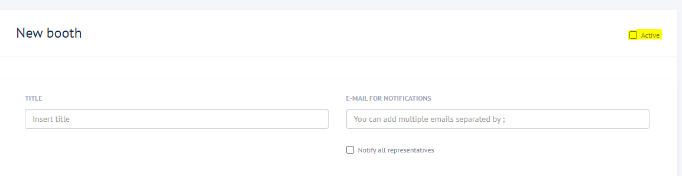
- If you click on "Poster Area" on the left menu, you should now be able to see the virtual booth you just created. You can edit your booth by clicking on "Edit Booth" at the top. Please note that your poster booth will be assigned to its topic category by the conference organizers after you finished your set-up.

If you have any questions, do not hesitate to reach out to us at info@agrivoltaics-conference.org!

We are looking forward to your presentation at the AgriVoltaics2022!

The AgriVoltaics Organizing Team

